

Team Captain Kit





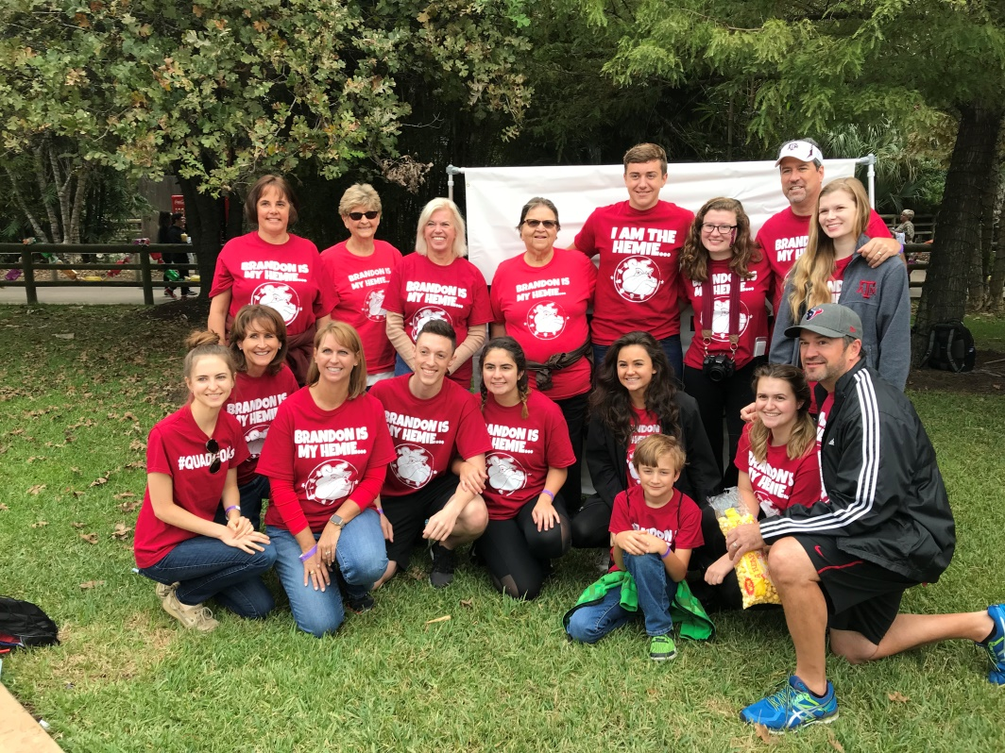

Table of Contents

Welcome and your impact

Register. Recruit. Raise Funds. Recognize.

Team captain checklist

Team goals

Who to recruit

What you fund

Name your team

Where to get t-shirts printed

Flyers you can print and use

Fundraising tools and ideas

Team roster and communication tracker

3

4

5

7

8

9

10

10

11

12

17

You’re a BIG DEAL and here’s WHY:

Teams raise 81% of all walk funds that pay for year-round programs for families right here on the islands.

As leader of your team, you have a powerful impact by helping to fund:

1. Koko Ohana to teach families how to manage their bleeding disorder and live a full, active life.
2. Emergency funds to help newly diagnosed families with unexpected expenses
3. Advocacy at the state capitol to make sure the needs of families with bleeding disorders are heard when laws are being written and passed.
4. Research into new treatments and research into genetic research to ultimately unlock a cure.

There’s more…

Let’s be clear, it feels good to spend time with family, friends, co-workers, and fellow bleeding disorder families proactively working for a great cause.

While the Unite Hawaii Walk is a once-a-year chance to reconnect with people who understand your journey like no one else does, the Unite Walk is truly a year-round community of families here to support each other.

It’s a chance for your team to show support for loved ones whose lives have been impacted by a bleeding disorder.

Thank you for being a team captain. Let’s get started…

Register. Recruit. Raise Funds. Recognize.

Every action you take as a team captain falls into one of four categories

Register. Your first step as a team captain is to [register](https://www.uniteforbleedingdisorders.donordrive.org) and create your team page. Your online team page will allow you and your team to easily track your team’s fundraising progress. Stuck for a name? We offer ideas later in this kit to stoke your thinking of a fun and meaningful team name.

Recruit. Spread the word and encourage others to join your team. Send an email to everyone you know asking them to join your team, or give a donation instead. See “How to Recruit Team Members” starting on page 7 for easy-peasy steps to recruiting a stellar team.

Raise funds. The Unite Walk is a fundraising event, so all team members are encouraged to raise funds online or offline. Help your team members get registered and encourage your members to set up a personal fundraising page where their friends, family, and co-workers can contribute easily to their efforts online.

New for 2018 are customized Unite social networking and fundraising tools, including an app designed for raising funds through Facebook. **Sign up to access all these new tools.**

Recognize. Recognition of your team members is a MUST for an effective team! Team members who reach certain levels of fundraising may be eligible for special prizes and incentives. See here what your team may qualify for. Be generous with emails, texts, and calls to let your team know you’re proud of their work.

Team Captain Checklist

Get started (3-4 months before your event)

□ Named your team something meaningful, inspiring, fun, or all three!

□ Set your team goals.

□ Registered yourself and your team (with you as team captain)

□ Customize your team page

□ Brainstorm who you want to recruit

□ Practice your recruitment script, especially “why we walk.”

□ Invite everyone on our list to join your team or support your efforts with a donation

□ Make sure all team members [register](http://www.uniteforbleedingdisorders.donordrive.org) (you can also register them when you register)

□ Have a kick-off call or meeting, especially if you’re a corporate team.

□ Check your company’s [matching gift policy here.](https://hemophiliawalk.donordrive.com/index.cfm?fuseaction=cms.page&id=1021)

□ Send e-mails to everyone you know asking them to join your team, or donate instead.

□ Place articles in your company newsletters or intranet site to recruit team members.

□ E-mail your team weekly with fundraising updates and be sure to highlight new team members with a hearty welcome.

Keep up your momentum (1-2 months before your event)

□ Send out fundraising e-mails to ask for donations and remind your team to send out their emails too! Click here for a [step-by-step video](https://hemophiliawalk.donordrive.com/index.cfm?fuseaction=cms.page&id=1023) on how to send an email.

□ Update the team page with personal stories, photos, and progress.

□ Distribute Unite Walk flyers to shops and restaurants in your neighborhood.

□ Host a team fundraising event (bake sale, garage sale, tip night, garage band challenge)

□ E-mail your team weekly with fundraising updates and recognize your top fundraisers

□ Collect team checks and cash. Make sure they are posted online, and turn them into Hawaii Chapter - NHF for confirmation

□ Order your custom team t-shirts if you’re planning on having them

The week before your event

□ Coach all your members to send one more fundraising email

□ Register any unregistered new team members

□ Email your team with all the event details: team meet up location, start time, where to get their team t-shirts, parking, and recognize all your fundraising leaders and anyone who has met the fundraising minimum

□ Post on social media to remind your friends to donate NOW

Event day

□ Arrive early

□ Register any unregistered new team members

□ Turn in to Hawaii Chapter - NHF any donations collected in person at event

□ Take team photos

□ Enjoy the day and bask in the feeling of doing something great

□ Post-event photos and team recognition on Facebook during and after the event

□ Thank each of your team members for being on your team via text, call, or email

Immediately after your event

□ Send thank-you notes to all your donors, with a team photo from the event (and send your team photo to your walk coordinator too!)

□ Send an email to all team members with team standings and event results

□ Send follow up e-mails to those who didn’t donate to you. Share your experience with them and give them one more chance to donate.

□ Collect and turn in any outstanding pledges

□ Host a team wrap party to thank your team members and enjoy your success

Team Goals

Research shows that when your team all shares the same goal, it dramatically boosts your success. Use this worksheet to set a high, yet attainable goal. You can always increase your goal if you hit it early.

Team Name _________________________________________________

Company (if applicable) ________________________________________

Team Captain ________________________________________________

Team Co-Captain (if applicable) _______________________________________

*Note: We recommend a co-captain for every 10 team members you recruit.*

Team Fundraising Goal

How many team members do I want to recruit? _______

Suggested amount raised per participant, **$100** or $_______

____________ **X** _________________ **=**  ____________________

# of Team Members Avg . Raised per team member Team Fundraising Goal

Now factor in any fundraising events your team will organize and hold.

­­­_____________________ ____________ ­­­­­­­­­­­­­­­­­­­­­___________________

Team Fundraising Activity Date Fundraising Goal

­­­_____________________ ____________ ­­­­­­­­­­­­­­­­­­­­­___________________

Team Fundraising Activity Date Fundraising Goal

**_________________ + ________________ = ____________________**

**Team Member Fundraising Event Fundraising Total Team Fundraising Goal**

Who to recruit

Everyone you know (the people THEY know) is a potential team member! Use this worksheet to **brainstorm the people** you want on your team.

Immediate bleeding disorder family (spouse, siblings, parents)

_______________________________ _______________________________

_______________________________ _______________________________

_______________________________ _______________________________

_______________________________ _______________________________

Extended family (aunts, uncles, cousins, grandparents)

_______________________________ _______________________________

_______________________________ _______________________________

_______________________________ _______________________________

Friends

_______________________________ _______________________________

_______________________________ _______________________________

_______________________________ _______________________________

_______________________________ _______________________________

Neighbors

_______________________________ _______________________________

_______________________________ _______________________________

Health care contacts (pharmacy, nurses, school nurse, doctors, insurance agent)

_______________________________ _______________________________

_______________________________ _______________________________

Work colleagues

_______________________________ _______________________________

_______________________________ _______________________________

School friends

_______________________________ _______________________________

_______________________________ _______________________________

Clubs, church or synagogue

_______________________________ _______________________________

_______________________________ _______________________________

**Register at: https://uniteforbleedingdisorders.donordrive.org**

What you fund…

We are a small but mighty community that takes care of each other.

Almost all of us have been helped by the Hawaii Chapter, and we unite to make sure that support continues for families that follow in our footsteps.

The way we give back to the community that supported us is a fun morning, Unite Walk funds vital services that aren’t covered by insurance.

**Emergency Funds** – We offer emergency funding for newly diagnosed families that have been hit with unexpected medical costs not covered by insurance. When your child or family member is first diagnosed, knowing your child or family member will get the care they need, even if you can’t afford it, profoundly eases the shock and stress.

**Community Education** – We host a variety of events throughout the year to provide our community with opportunities to connect with each other, and to create awareness about bleeding disorders.

**Teen Programs** - Our teen programs focus on developing teen leadership skills with retreats, volunteer activities, advocacy awareness with a trip to our state capital, and just spending time with fellow bleeding disorder teens.

**Camp** –By far, our most popular training program does more than train ohana how to manage their bleeding disorder. Camp gives ohana the confidence to reach for the stars and do anything in spite of their bleeding disorder.

**Advocacy** –Health care is in the headlines almost daily, and we’re on top of any changes to coverage for families living with a bleeding disorder both nationally and locally.

**Research** – One of our goals is a world without bleeds. We truly believe that genetic research is key to getting us there. Until we find a cure, we also support research into new treatments.

Name your Team! (Make it personal. Make it fun!)

Create a sense of fun, mission, and belonging to your team name. You can show a loved one support by naming the team after them. Show company pride with a company team name.   
  
Or you can go crazy and come up with the funniest name you can think of.

Here are some example team names to stoke your creative juices.

United for [Name of honoree]

[Name of Honoree]’s Heroes

[Name of Honoree]’s Posse

[Name of Honoree]’s Buddies

[Name of Honoree]’s Warriors

Team [Name of Company]

The Funny Factors

The “X” Factors

The Wow Factors

Where to get team t-shirts made

A lot of teams get t-shirts printed with their team name to deepen the team experience.

We recommend that you place your t-shirt order 1-2 months in advance of our event. Here are some vendors other team captains have used:

Contact Chapter if you need suggestions

Hand out or post flyers

Recruit members to your team with these handy flyers you can get from your walk coordinator.

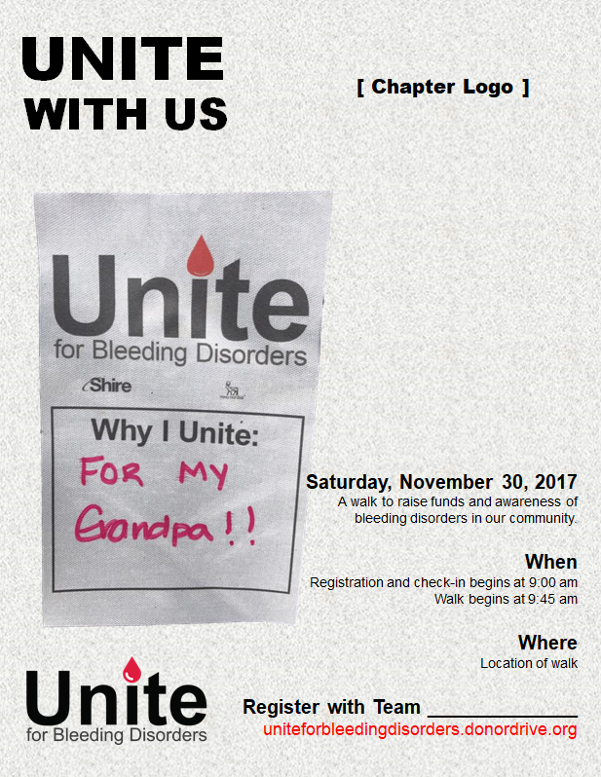

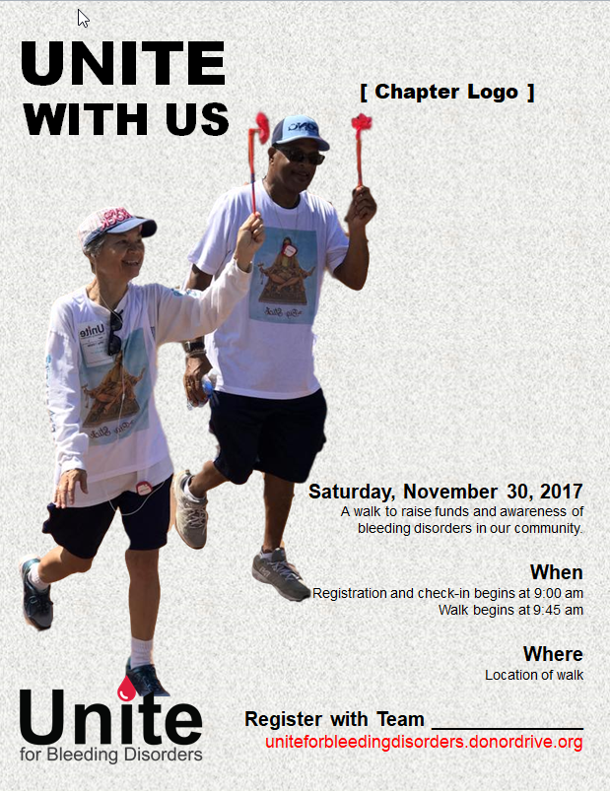

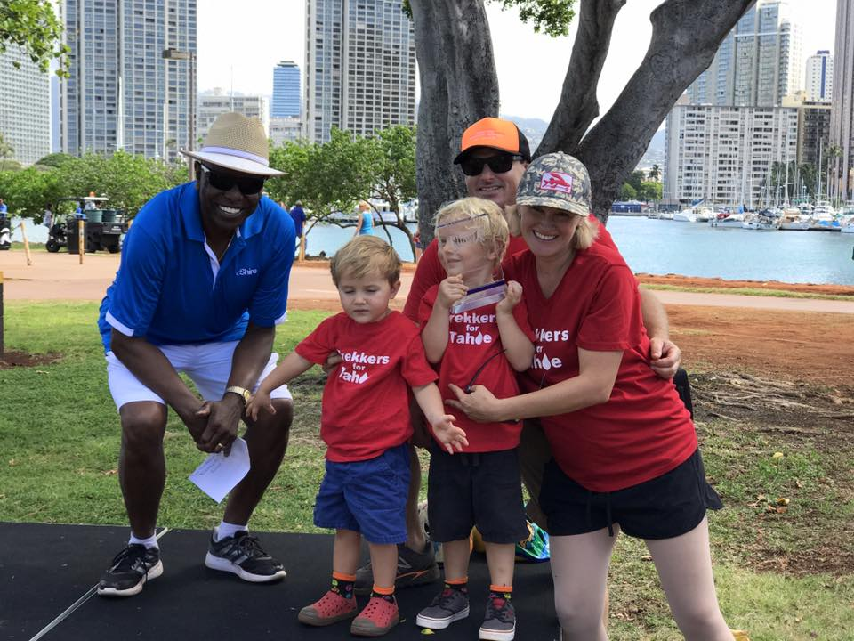

Fundraising Tools

Fundraising Tools and ideas

Coach your team to use the Unite Mobile App

Download the Unite for Bleeding Disorders app from the App Store or Google Play to your phone or tablet. It’s the easiest way to send email and text all of the contacts on your device. You can also post to social media from the app.

You can always find the installation links on your **Fundraising Dashboard.** Just click these links to install the Unite mobile app for Facebook or mobile.



Run a “Factor VII Challenge” to raise $200

Raising money is easier when you’re not alone.

As a team captain, here’s fun fundraising activity to help each team member raise $200 in less than one week.

Choose a “Factor VII Challenge” week where everyone on your team uses the following daily schedule to raise $200 in one week! What a way to boost your team goal!

Plan to set up a Facebook Group or email thread with all team members on it share daily updates stories to build a sense of community and competition as the week goes on.

Day 1 Sponsor yourself with a $25 donation $25

Day **2** Ask **2** relatives for $20 each $40

Day **3**  Ask **3** friends for $15 each $45

Day **4** Ask **4** co-workers for $10 each $40

Day **5**  Ask **5** neighbors for $5 each $25

Day 6 Ask your husband, wife, or significant other for $25 $25

Day 7 **Celebrate** that you just raised $200 in ONE WEEK!

Host a team fundraising day (or two)

Part of being on a team is enjoying a social get together. Here are some ideas that raise money while having a good bit of fun and building camaraderie.

* Theme party (come as your favorite Game of Thrones character)
* Host a fun movie night with snacks, drinks and a beloved movie. Have everyone attending donate what they would have paid at the theater
* Host a red party – fitting for a bleeding disorder, dress in red, serve red foods, drink red drinks
* Host a happy hour party where you serve drinks and munchies and attendees donate what they would have spent at a happy hour
* Host a garage band competition
* Conduct a silent auction
* Host a garage sale
* Host a bake sale (seriously, these are still wildly popular)
* Host a Saturday morning car wash
* Collect bottles for redemption



Coach your team on how to ask in 5 easy steps

Asking for a donation can be hard, unless you use this sure-fire script. Coach your team members to use this script to make asking for a donation easy!

**1. Identify the need you are trying to address.** Example: “1 in 4,500 boys are born with Hemophilia.” Or “von Willebrand disease is more often misdiagnosed (70.6%) than correctly diagnosed (29.4%), which means our daughters and sisters experiencing excessive bleeding aren’t getting the right treatment… yet.”

**2. Explain why it is important to you.** Example: “My niece was diagnosed with von Willebrand’s disease and I want her to know how much I love and support her to find better diagnosis, treatments, and a cure.”

**3. Share what you are doing about it.** Example: “I am part of a team in the Unite for Bleeding Disorders Walk on May 15 to help raise funds to pay for the training, care, and research into cures for bleeding disorders including von Willebrand’s disease, Hemophilia, and Factor II, V, VII, X, or XII deficiencies.”

**4. Ask your donor to take a specific action.** Example: “Will you make a $50 donation to the Hemophilia Foundation, to support of families living in our community with a bleeding disorder?”

**5. Stop talking and let your donor answer.**

Sample team member recruitment script

Use this script to inspire your team member recruitment calls, emails, and texts.

Only 25% of women living with von Willebrand’s disease are diagnosed correctly.

What’s von Willebrand’s disease? It’s actually the largest bleeding disorder. It mostly affects females and causes excessive bruising and dangerously excessive menstrual bleeding.

And, it runs in families.

My niece was recently diagnosed and is now finally getting the treatment she needs.

To show her my support, I’m leading a team, [[TEAM NAME]], in the Unite for Bleeding Disorders Walk, the nation's largest event to raise awareness and funds to fight bleeding disorders.

We’re uniting for a fun and inspiring day on [[Day, Date, at Location]] to Unite for Bleeding Disorders [[EVENT]]

All the funds raised go to support local families affected by Hemophilia, von Willebrand disease, and Factor II, V, VII, X, or XII deficiencies, with training programs, education, emergency funds, teen programs, and advocacy at the state capitol.

The end of bleeds starts with us.

Please join my team!

Contact me at [[YOUR CONTACT INFO]] to find out how to register or logon to my team page at [[YOUR TEAMPAGE LINK]] and register online right now.

Team Captain

P.S. If you can’t join us in person, you can be a member of our team virtually too! Just select “virtual walker” when you register. Or, if you can’t do either, please make a donation to show your support.

**Need a quick tutorial on how to send an email? Check out a step-by-step video on how to** [**send an email**](https://hemophiliawalk.donordrive.com/index.cfm?fuseaction=cms.page&id=1023)**.**

Team roster

Let’s be honest. We lost one of our two offspring in a grocery store once, so keeping track of five, ten, twenty, or more team members can be a challenge.

On the next page we have a roster-tracker to make your life easier. Take five minutes to print the roster out and jot down all your members’ info. Trust us, you’ll thank us later.

More than that, we added some key notifications you’ll want to check off when you’ve connected with each team member.

Contact with your team members by telephone is best, but whether you contact your team members in person, on the phone, text, or email, **it’s important for you to stay in touch so they feel valued and like they belong.**

The minimum basic team communications you’ll have with each team member are:

* **Welcome to the team!** Warmly welcome each member to the team within 24 hours of registering. Remind them of the important impact they’ll have.
* **Congrats on hitting your fundraising goal.** Once your team member hits their fundraising goal, be sure to congratulate them personally, recognize them publicly for their achievement to both your team and the mission, and encourage them to increase their goal and keep fundraising!
* **How can I help you hit your fundraising goal?** Make at least one, if not two, or three calls to support team members that haven’t yet hit their fundraising goal. Coach them with any one of the fundraising tools we’ve made available to you.
* **Event day logistics and excitement.** 72 to 48 hours before your event, you’ll want to get your team excited about their event day experience and give them instructions where and when to meet
* **Thank you for being a valuable member of our team!** You’ll thank each member for being part of your team with every contact, but be sure to send a special post-even thank you. Maybe include a team photo. Be sure to thank your team member for their valuable contribution and remind them of the good work you’ve helped to fund.

|  |  |  |  |  |  |  |  |  |
| --- | --- | --- | --- | --- | --- | --- | --- | --- |
| **TEAM MEMBER** | **PHONE OR TEXT** | **EMAIL** | **Fund-raising GOAL** | **Welcome ✓** | **Congrats ✓** | **Coaching ✓** | **Event Day Logistics ✓** | **Thank you ✓** |
|  |  |  |  |  |  |  |  |  |
|  |  |  |  |  |  |  |  |  |
|  |  |  |  |  |  |  |  |  |
|  |  |  |  |  |  |  |  |  |
|  |  |  |  |  |  |  |  |  |
|  |  |  |  |  |  |  |  |  |
|  |  |  |  |  |  |  |  |  |
|  |  |  |  |  |  |  |  |  |
|  |  |  |  |  |  |  |  |  |
|  |  |  |  |  |  |  |  |  |
|  |  |  |  |  |  |  |  |  |
|  |  |  |  |  |  |  |  |  |
|  |  |  |  |  |  |  |  |  |
|  |  |  |  |  |  |  |  |  |
|  |  |  |  |  |  |  |  |  |
|  |  |  |  |  |  |  |  |  |
|  |  |  |  |  |  |  |  |  |
|  |  |  |  |  |  |  |  |  |
|  |  |  |  |  |  |  |  |  |
|  |  |  |  |  |  |  |  |  |
|  |  |  |  |  |  |  |  |  |
|  |  |  |  |  |  |  |  |  |
|  |  |  |  |  |  |  |  |  |
|  |  |  |  |  |  |  |  |  |
|  |  |  |  |  |  |  |  |  |
|  |  |  |  |  |  |  |  |  |
|  |  |  |  |  |  |  |  |  |
|  |  |  |  |  |  |  |  |  |
|  |  |  |  |  |  |  |  |  |
|  |  |  |  |  |  |  |  |  |



We’re here to help you.

Thank you for being a team captain!